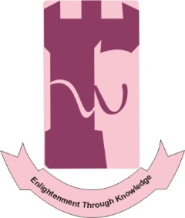
CALL FOR PAPERS
NATIONAL CONFERENCE ON
“MAINSTREAMING TRIBAL AREAS IN KHYBER PAKHTUNKHWA: PROSPECTS AND CHALLENGES”
Organised by
Shaheed Benazir Bhutto Women University, Peshawar.
24 October 2018 - 25 October 2018 | Peshawar.
OBJECTIVES OF CONFERENCE:

The conference broadly aims at achieving the following objectives:
- To discuss the socio-cultural, economic and political opportunities that are created for the tribal people.

- To debate and discuss the security, political, economic advantages that would be derived from the merger for Khyber Pakhtunkhwa in particular and for Pakistan and the region in general.

- To deliberate upon the constraints and challenges which may hamper the mainstreaming of tribal districts in Khyber Pakhtunkhwa smoothly. At the same time, the conference aims at formulating recommendations/suggestions for overcoming these challenges.

NATIONAL CONFERENCE SUB-THEMES
The conference invites papers on, but not limited to the following sub-themes:
- Mainstreaming tribal areas in KP and Socio-Cultural Issues
- Political and Administrative Issues
- Security Issues
- Economic Opportunities and Challenges
Important Dates:
- Abstract Submission Deadline: 13th August 2018
- Notification of Acceptance: 20th August 2018
- Deadline for the Submission of Research Paper: 8th October 2018.
Both Abstract and Complete Papers should be submitted on the following e-mail address.
tdkp2018@sbbwu.edu.pk

Venue:
- Shaheed Benazir Bhutto Women University, LARAMA, Charsadda Road, Peshawar.
Contact US:
ORIC: +92-91-9224793
Department of Political Science: +92-91-9224771
Email: pscience@sbbwu.edu.pk

Conference Documentation:
Please visit our website:
http://www.sbbwu.edu.pk/sbbwu/

Note: TA / DA will be paid as per rules along with accommodation and nominal honorarium.

